<https://www.udemy.com/>



<https://about.udemy.com/company/?locale=en-us#offices>

Bad usability:

🡺you must search for somewhere (contact us) allows you to visit their social medias.

Good usability:

🡺footer isn’t too big

<https://www.udacity.com/>

Good usability:

🡺you can easily find their social medias.

Bad usability:

🡺footer is too big. Too large font-size

<https://www.dominos.com.eg/ar/pages/customer/#!/customer/profile/new>

Bad readability

🡺font size too small

Showing a hint that the star means required

<https://www.egypt.pizzahut.me/ar/home>

Good readability

🡺better font size



Good readability

🡺showing that this is the code of Egypt.

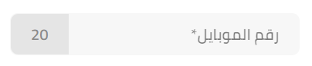

Bad readability

🡺some people doesn’t know their country code number

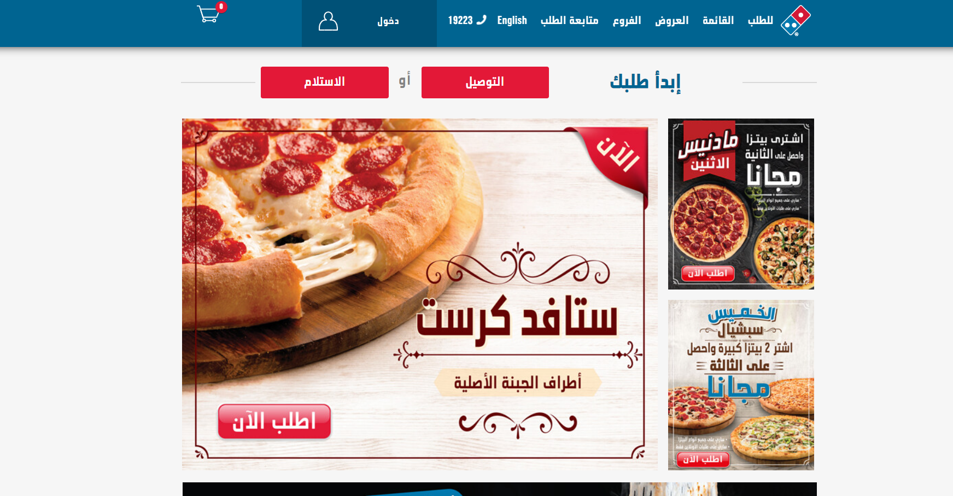

Bad

🡺landing page only showing offers

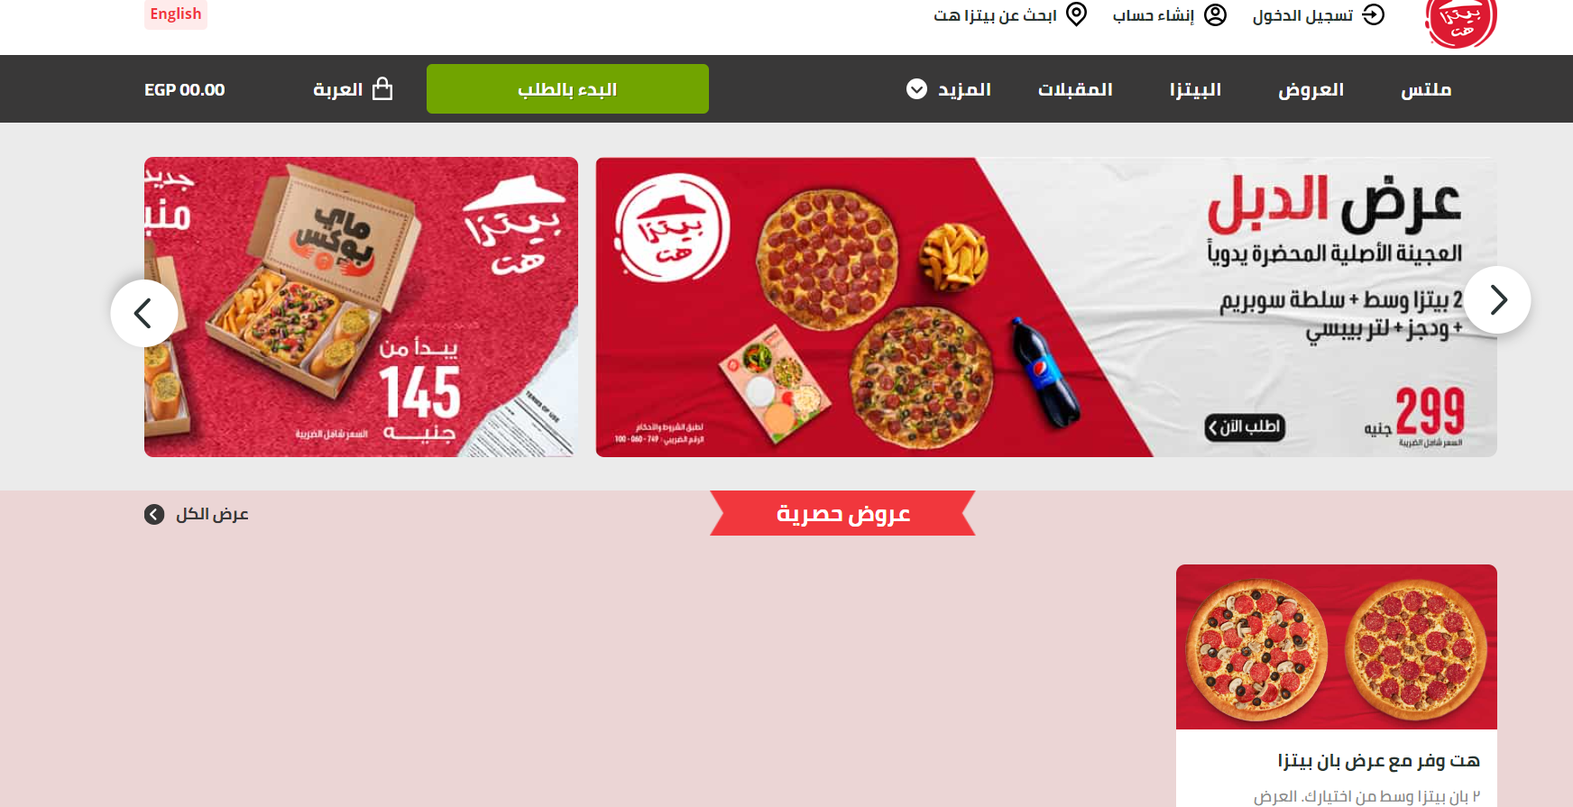

Good

🡺showing a hint about their pizza’s prices as well as some offers

Good

U can simply find the menu



Bad

The menu is divided into various words.

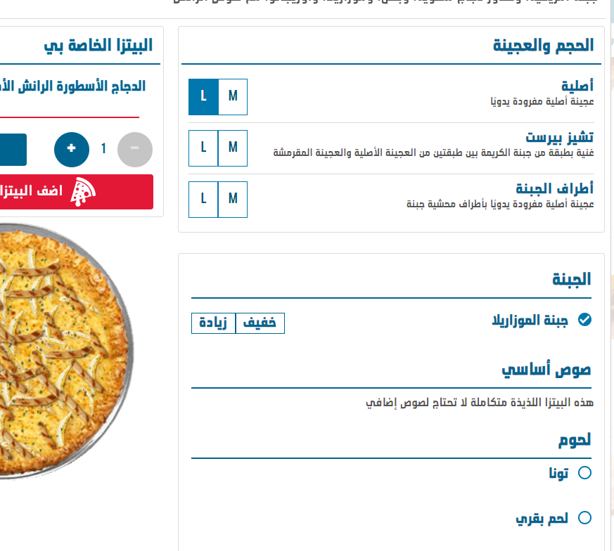

Bad ordering process

Can’t tell users location accurately

Fill your address manually

Users can’t know what are the prices of the pizza until adding to cart

Asks for location before adding to cart

More serious border raduis

Better ordering process

Get my accurate location.

Get your address data correctly.

You can know the price of the pizzas before ordering.

Add to cart first before sharing location.

Better border radius

Moving cart while scrolling is annoying

Could be with smaller element

Fixed cart while scrolling is better for big elements